**Mastering Linux AWK and CUT commands: Essential Linux skills for beginners**

* AWK is a text processing command
* Awk command is used to scan for a certain text in an entire file
* Not going to run it on my system
* Will only share ss of what he has run
* Say we have a file named data(a csv file) with rows and columns
* Now we want to only print data from the 2nd column then we can run command – awk ‘{print $2}’ data (give the file name here)

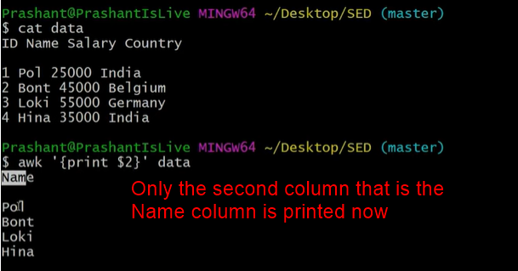

* Now say I want to print columns Name and Country both
* Then we can just give command as – awk ‘{print $2,$4}’ data

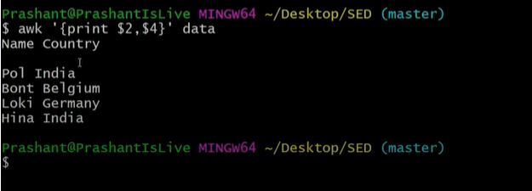

* So awk basically goes through each line one by one, and ${value} , here value is the field
* So in each line it will find the 2nd word and print it
* Similarly for $4, it will print the 4th word and print it
* Command to print only the last column – awk ‘{print $NF}’ data

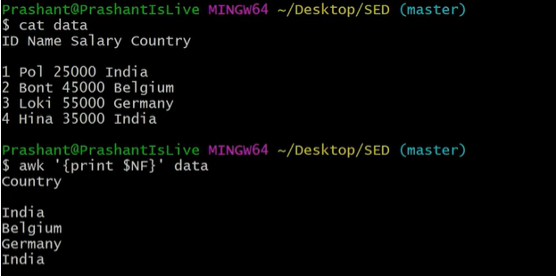

* When we run ls -ltr we usually get space separated values
* Now say I only want to print only the permissions and names run command - ls -ltr | awk '{print $1,$NF}'

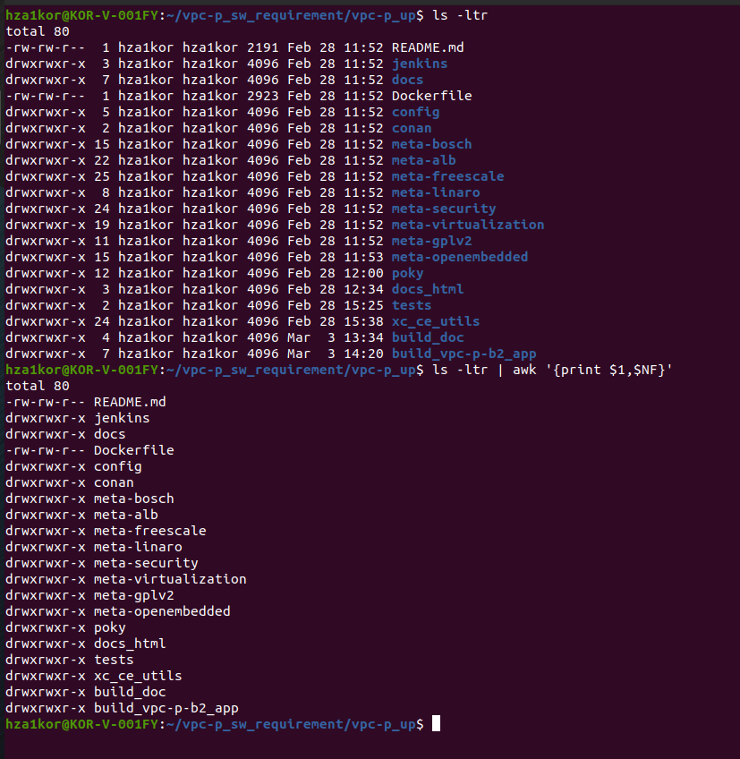

* Say I have a file named “names” with names of multiple people
* Now there are no numbers before the names I want numbers in front of the names
* Then we can run command – awk ‘{print NR $0}’ names



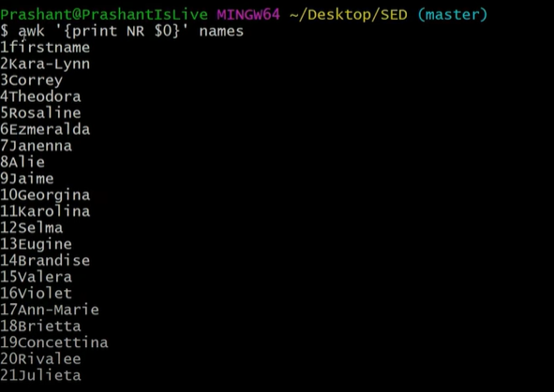

* To make it more readable, like there should be a space gap between number and name then we can run command – awk ‘{print NR, $0}’ names

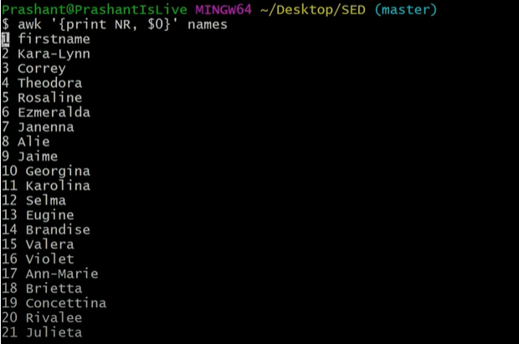

* Say I want a collan separation between numbers and the names we can use the command – awk ‘{print NR “: ” $0}’ names

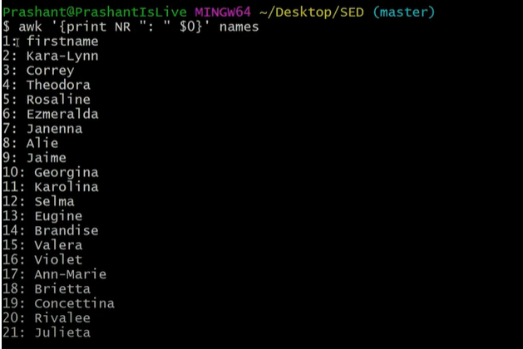

* Say I have a csv file which is comma separated and not space separated, for those cases also we can use awk command
* Here we have a country.txt file where all fields are comma separated, now say we want to extract certain columns like I want only the email column then we can run command – awk -F, ‘{print $4}’ country.txt



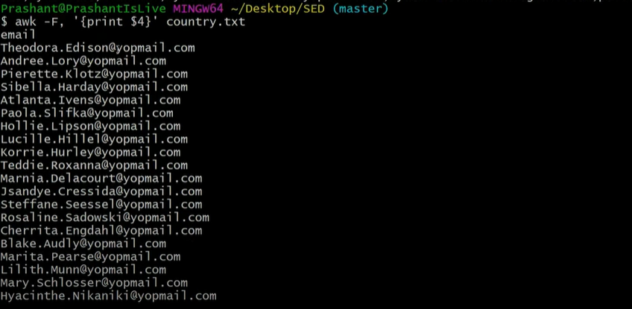

* Say now I want only the countries then we can run command - awk -F, ‘{print $7}’ country.txt

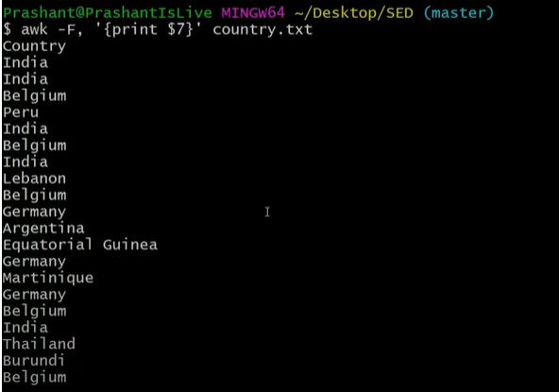

* **Conditions using awk –**
* Say I have a data file with ID, Name, Salary and Country

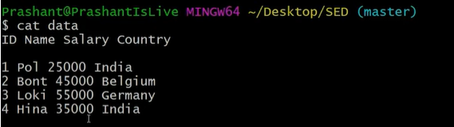

* Eg1 - Now my requirement is that only print the data whose salary is greater than 40000
* Then we can run command – awk ‘{if($3>40000) print $0}’ data

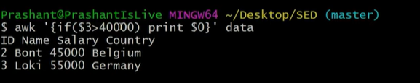

* Eg2 – Now say my requirement is that I want to change the salary for Pol from 25000 to 80000

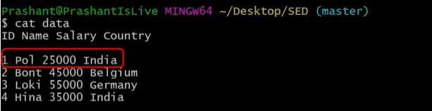

* Then we can run command – awk ‘{if($2==”Pol”) {$3=80000} print $0}’ data

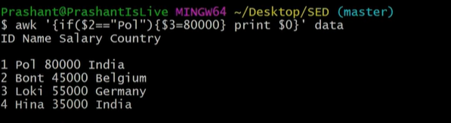

* Eg3 – say we have a country.txt file and we only want to print lines with “India” in it



* Then we can run command – awk ‘/India/ {print $0}’ country.txt

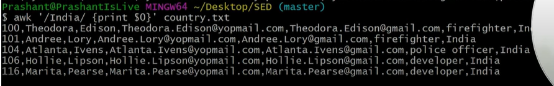

* Eg4 – Now say I want to add serial number to all the lines in country.txt run command – awk ‘{print NR “- ” $0}’ country.txt

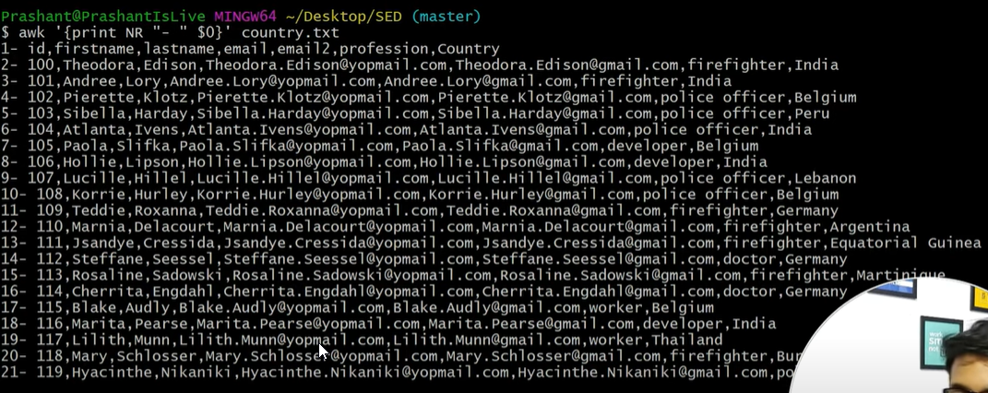

* Eg5 – Say now I want to only print line 8, then we can run command – awk ‘NR==”8” {print $0}’ country.txt



* Eg6 – Say now I want to print a range of values from 8 to 10 then we can run the command - awk ‘NR==”8”, NR==”10” {print $0}’ country.txt



* Eg7 – Say I want to print all the empty lines inside a file , here we have a file named data and here 2nd row is free

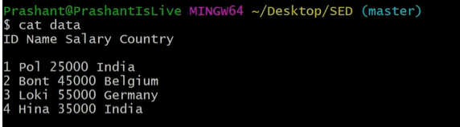

* Now we can see that the 2nd line is empty, now to find all the empty line numbers in the data file we can run the command – awk ‘NF==0 {print NR}’ data

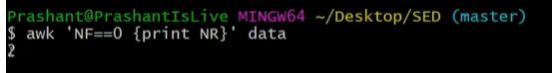

* Eg8 – Say now the requirement is to know the number of lines inside country.txt



* We can now run the command – awk ‘END {print NR}’ country.txt



* Eg9 – for loop using awk command
* Say I have a requirement to print 0 – 10 using awk command
* Then we can run the command – awk ‘BEGIN {for(i=0;i<=10;i++) print i;}’

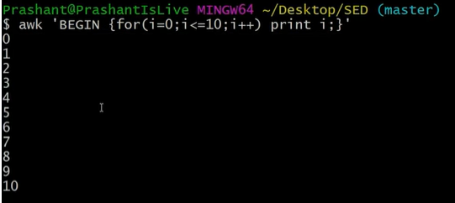

* Eg10 – while loop using awk command
* To print numbers from 0 -10 using awk with while command – awk ‘BEGIN {while(i<10) {i++; print “num is ” i} }’

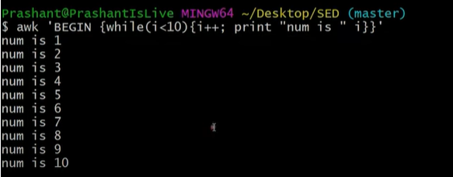

* **CUT Command –**
* Cut command is used when we have to do processing on character level
* Say we have a file named “names”

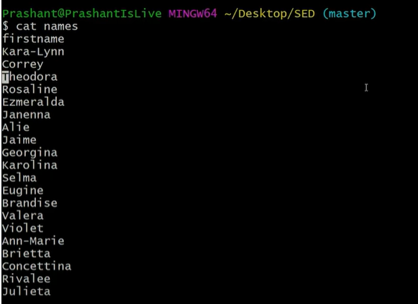

* Eg1 - Now my requirement is to only print the first letter of each name
* Then we can use cut command – cut -c1 names
* Here c means character and 1 means 1st character

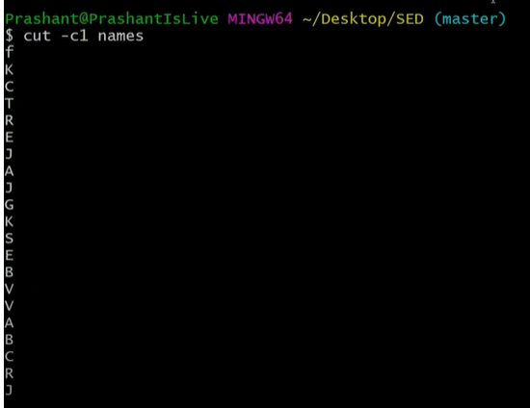

* Eg 2 – say now requirement is to have 1st and 5th character printed then we can run the command – cut -c1,5 names

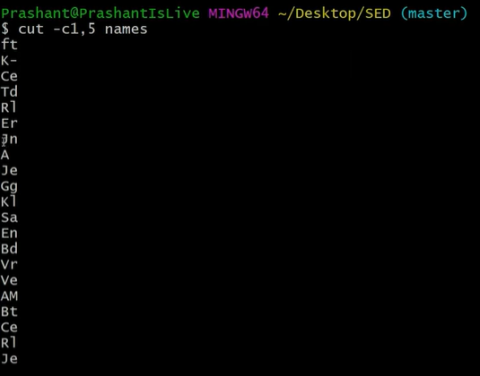

* Eg3 – say now I need range of character printed from 1st to 5th then we can run the command – cut -c1-5 names

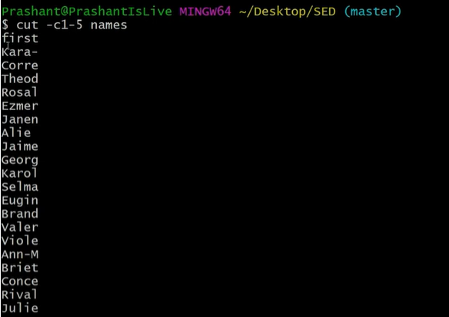

* Eg4 – say I have a csv file where fields are comma separated, now my requirement is to print all the firstnames using cut command



* Then we can run the command – **cut -d, -f 2 country.txt**(here -d is the delimiter to tell us how the fields are separated, -f is the field we need firstname which is the 2nd column)



* Eg5 – say I have a csv file county.txt which is comma separated, now I want to replace the comma separator with the pipe(|) separator

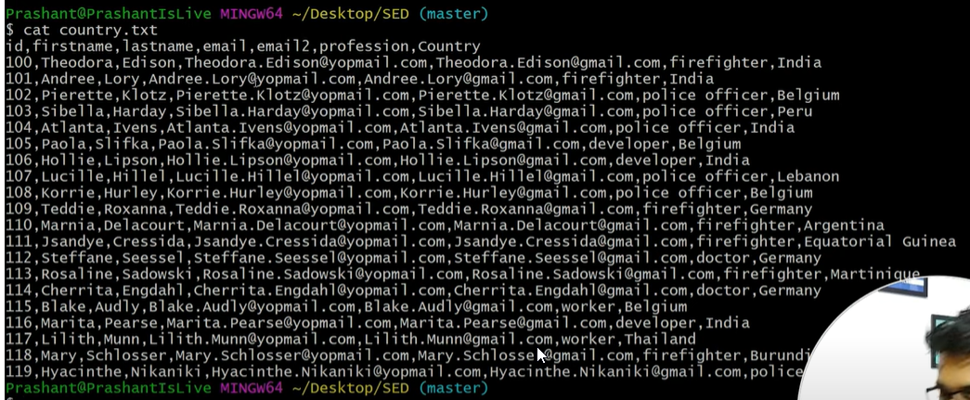

* Then we can run command – **cut -d, -f 1- country.txt –output-delimiter=” | ”**



* **Using awk with cut**
* Eg6 – say I have a list of directories, now I have to use awk and cut command to print only the first 2 characters from the name

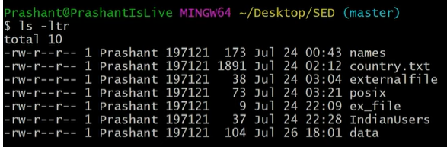

* To print only the names of the files and directories we can use awk command – ls -ltr | awk ‘{print $NF}’

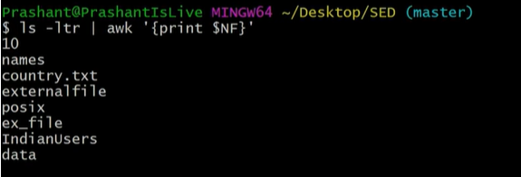

* Now we get the names, but to print only the first 2 characters we can run command: ls -ltr | awk ‘{print $NF}’ | cut -c1,2

